XK01 – Create Vendor Account

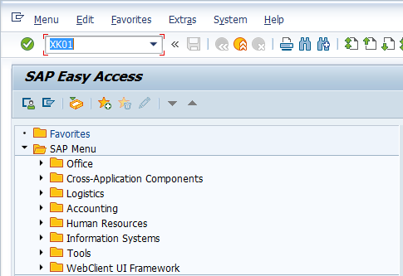

- Input XK01 in Transaction Box and press Enter key

Create Vendor Initial Screen.

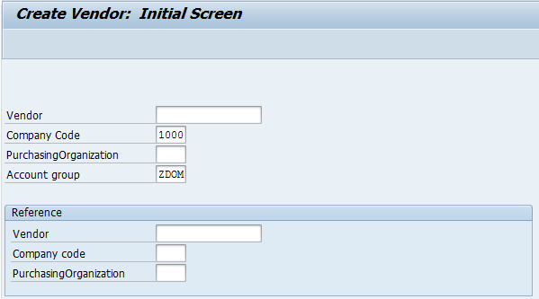

- Company Code: Input company code
- Account group: Input vendor account group or select it with the help of F4 key
Press Enter key

Create Vendor Address Screen.

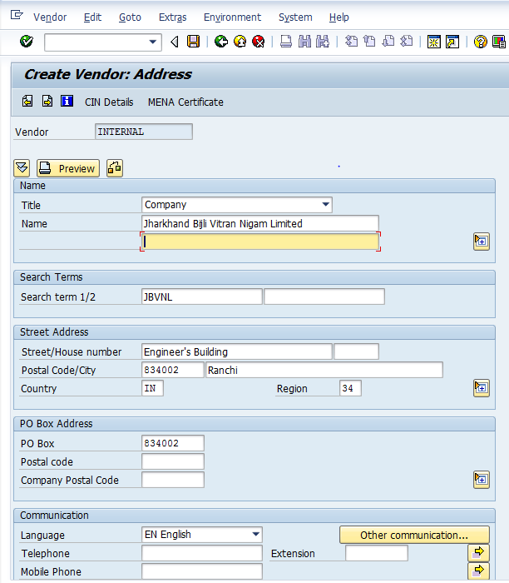

- Title: Select relevant title from the drop down
- Name: Input vendor name
- Search term 1/2: Input required/relevant search term
- Street/House number: Input steet and house number
- Postal Code/City: Input postal code and city
- Country: Select country code with the help of F4 key
- Region: Select region code with the help of F4 Key
Press Enter key

Create Vendor Accounting Information Screen.

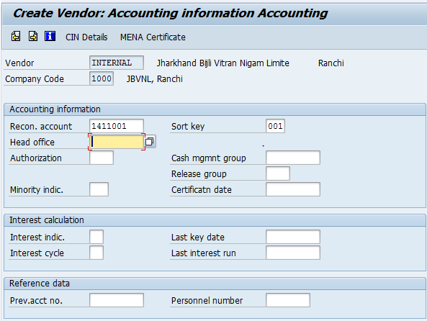

- Recon. account: Select the relevant reconcialiation account with the help of F4 key
- Sort Key: Select the relevant sort key with the help of F4 key
Press Enter key

Create Vendor Payment Transactions Accounting Screen.

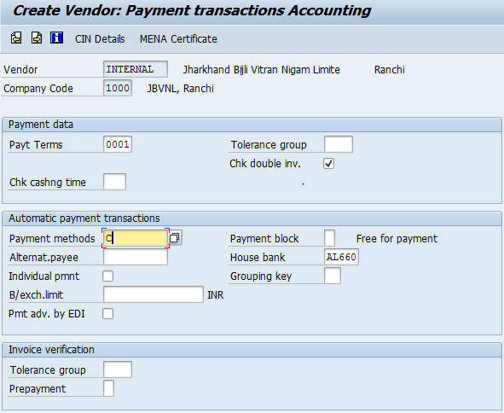

- Payt Terms: Select the relevant payment terms with the help of F4 key
- Chk double inv.: Select the option to avoid the duplication of Invoice
- Payment methods: Select the relevant payment metod with the help of F4 key
- House Bank: Select the relevant house bank with the help of F4 key
Pess Enter key

Create Vendor Payment Transactions Accounting Screen.

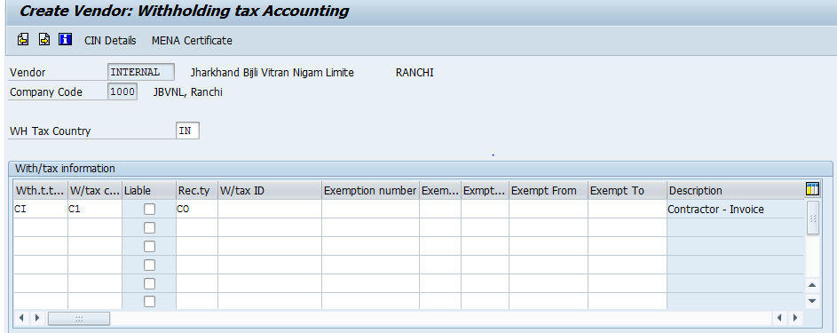

- WH Tax Country: Select the relevant withholding tax country code with the help of F4 key
- With/tax information: Input the relevant tax information detail or use F4 key to select the same
Click on Save icon or press Ctrl+S keys to save the data

Vendor was successfully created message appears at bottom of the screen

Manual End

